Network Security
Student Name: Emmanuel Opara
Eagle ID: 901305850

Module 02 – Ciphers –RSA – Hash Functions – Steganography

- RSA. Go to http://travistidwell.com/jsencrypt/demo/. There are four different lengths of key pair that can be generated (512, 1024, 2048 and 4096 bits). For each of these key lengths, first generate the new keys (may take a while for longer keys), then encrypt the text of your choice at the bottom of the webpage and paste below screenshot for each encryption result showing the private key, the public key and the ciphertext. (20 points)
For Key Length 512bits. The plain text I used here was “Advanced Network Security”, the cipher text is shown in the screenshots below. The public key and private key are displayed in the screenshot below.

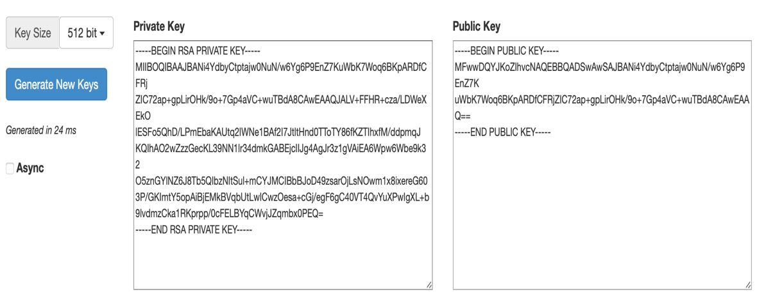

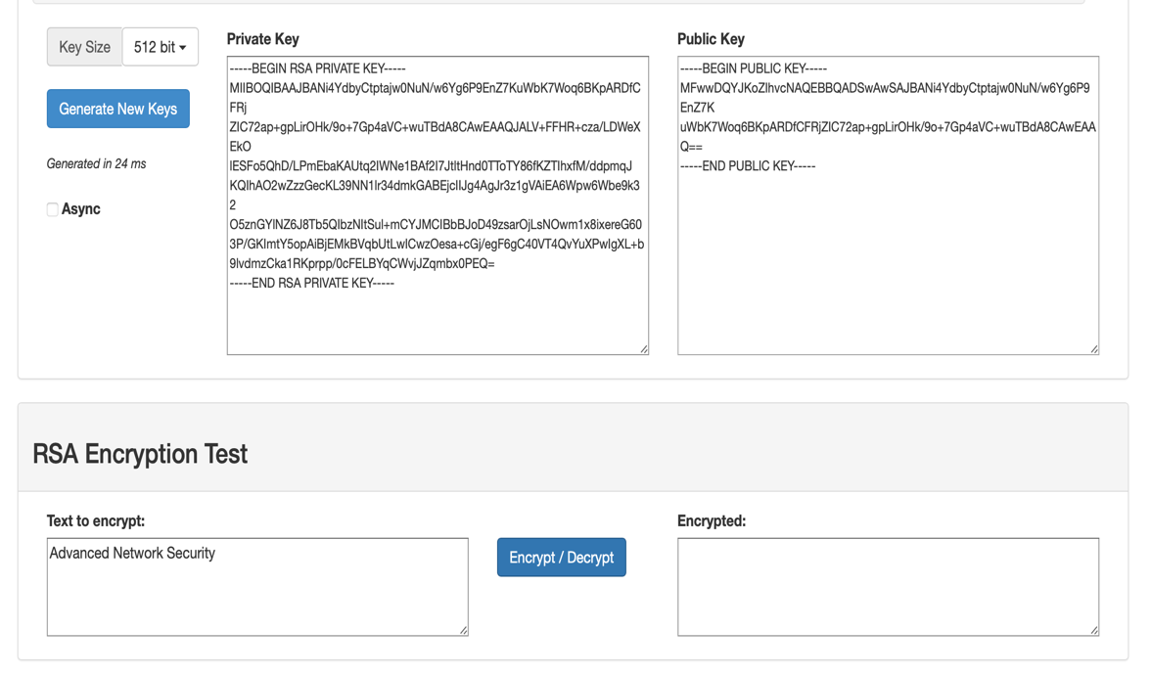

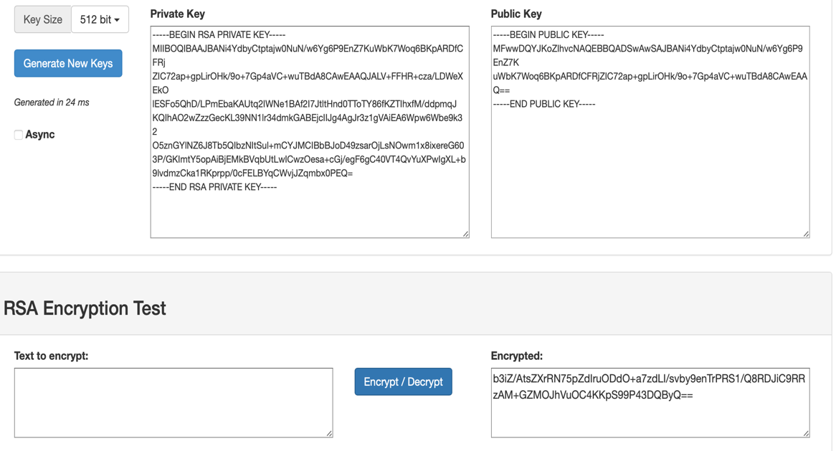

For Key Length 1024bits. The plaintext I used was Computer Network Security. The ciphertext is generated after encryption. The public key and private key generated are shown below.
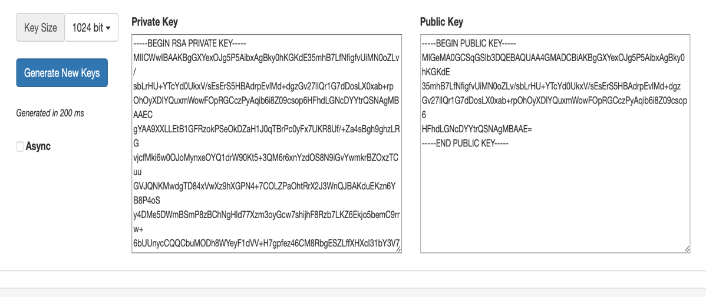
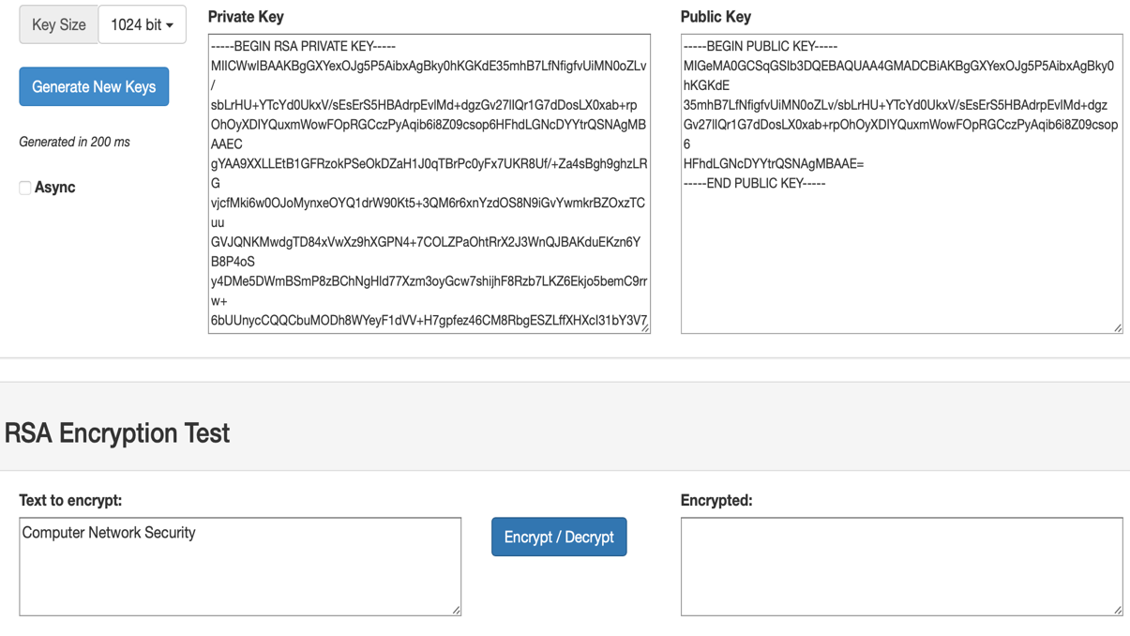

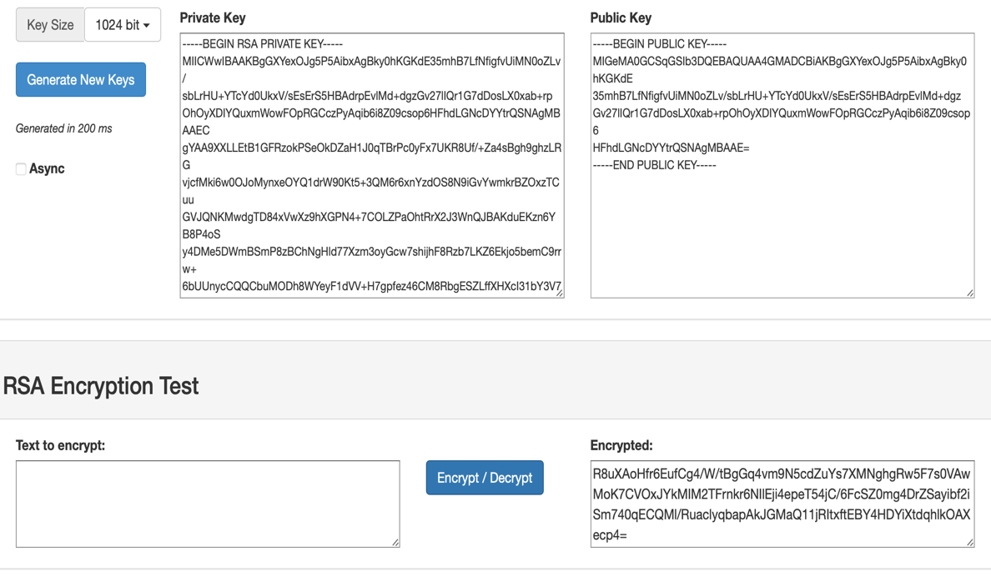

For Key Length 2048 bits. The plaintext I used was Computer Network Security. The ciphertext is generated after encryption. The public and private key are shown below.
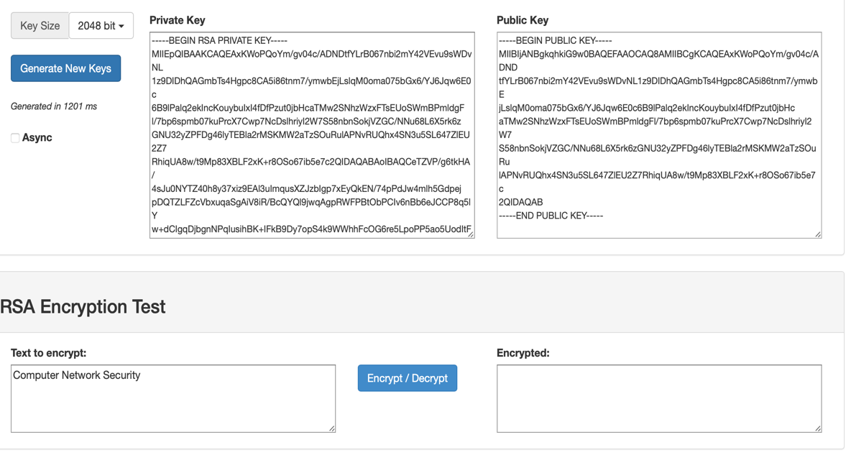
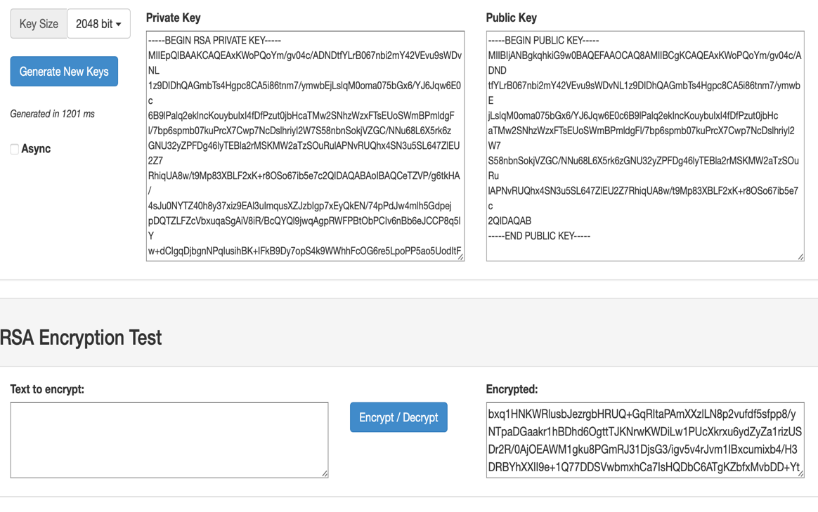
For Key Length 4096bits. The plaintext I used was Computer Network Security. The ciphertext is generated after encryption. The public and private key are shown below.

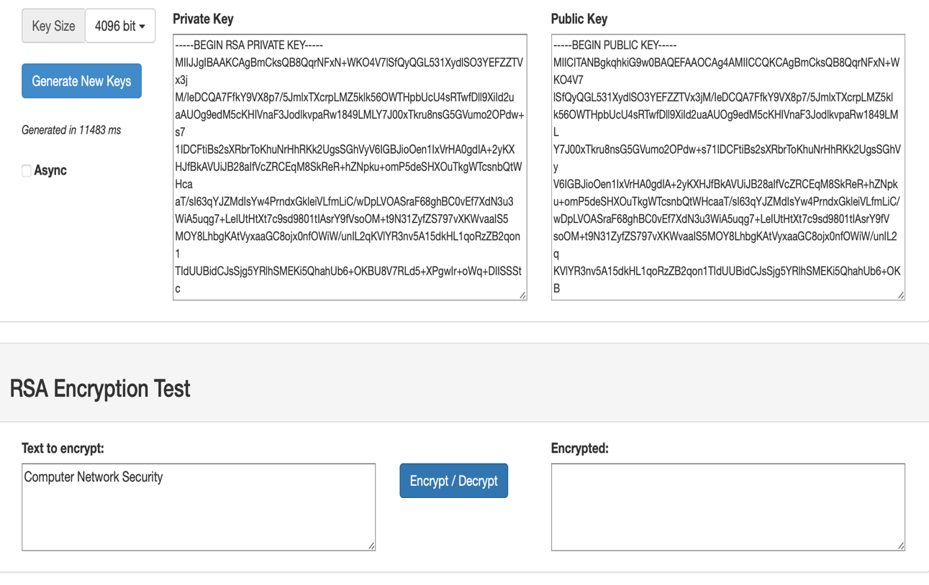

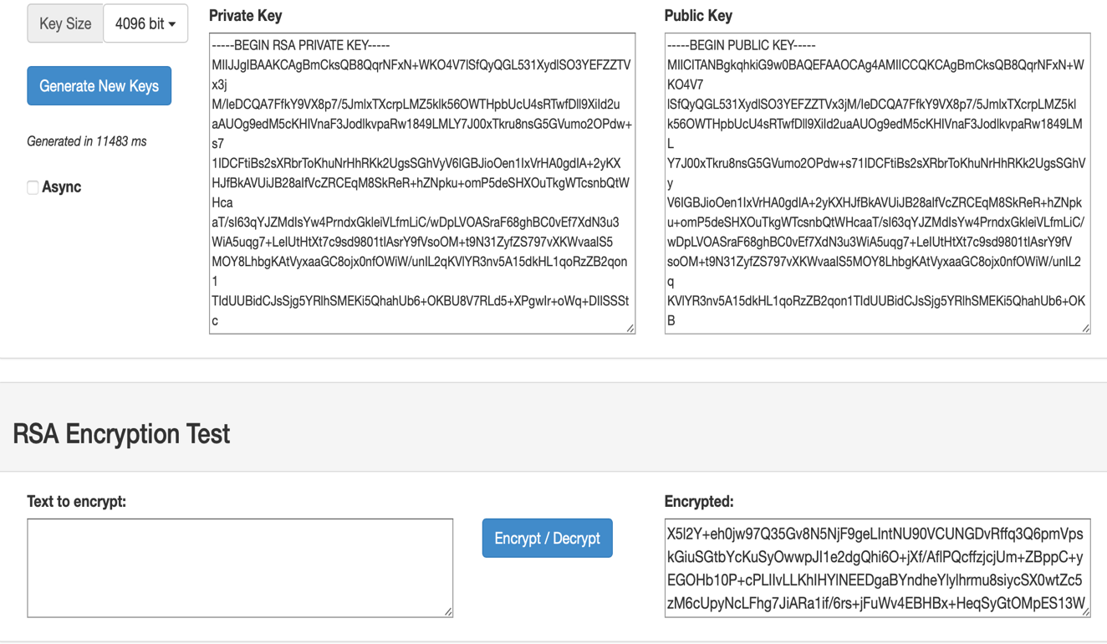

- Secure Hash Algorithm (SHA). Hash, using SHA-256, the same text file (e.g., .txt) of your choice using each of the following methods. (25 points)
  - Go to https://emn178.github.io/online-tools/md5.html. Copy and paste below the hash value result. (5 points)
1566e2f6d4bc5c15b2b4cfd2ab2ef67643e868bfe67f6fabeb543c8601f25f87

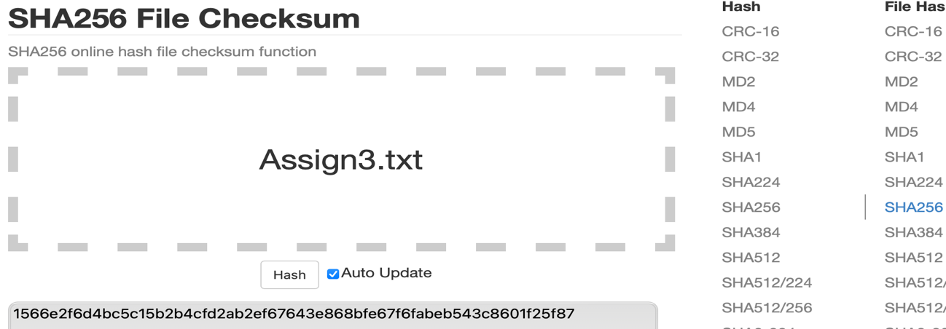

  - Search online for a free SHA-256 tool that works on Windows. Download and install the tool. Specify below the name, version of the tool and where (URL) it was downloaded. Then run the tool to hash the same text file; copy and paste the hash value below. (7 points)
For this question, I downloaded the tool called HashMaker for Mac OS.
Name: HashMaker
Version: Version 1.0 (1) Copyright © 2012 Hawark Li Inc. All rights reserved.
Where: AppStore
URL: https://apps.apple.com/us/app/hashmaker/id509733654?mt=12

Then I used the same text file “Assign3”, and hash SHA-256 to generate a hash value for the file. I observed that both hash values are the same. The screenshot below shows the tool and the hash value generated after inputting the file through the browser button on the tool. The tool allows comparisons of hash values between text files and strings.
1566e2f6d4bc5c15b2b4cfd2ab2ef67643e868bfe67f6fabeb543c8601f25f87

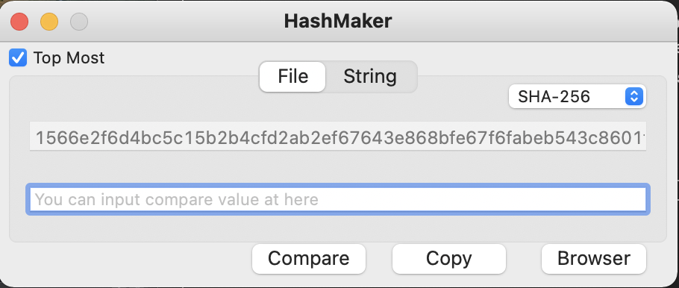

  - In a Linux system, e.g., Ubuntu virtual machine or Kali Linux you already have, use the command sha256sum to hash the exact same text file (for this purpose, you can email to yourself the same txt file as attachment from Windows and download it on Linux). Paste below screenshot showing your command and produced hash value as proof. You may run command man sha256sum to see the manual page of this command if needed. (8 points)

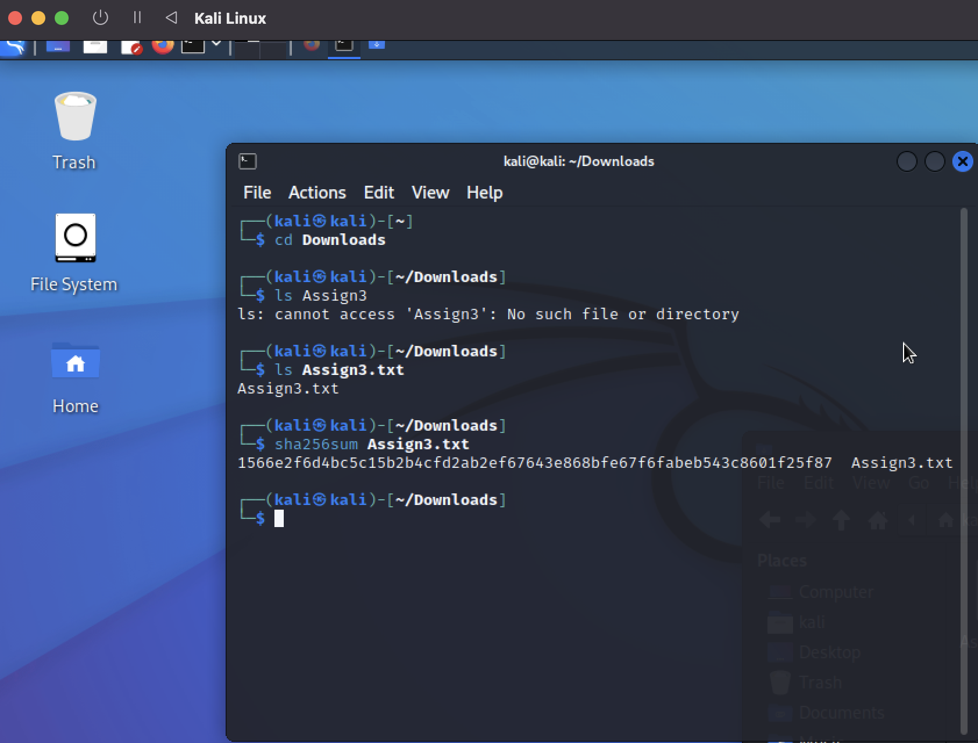

  - What is your finding and conclusion based on a), b) and c) above? (5 points)
In question 2a, 2b, 2c, I observed that when using the same text file as the input for different tools and different operating system, the Hash Value generated remained the same. This concludes that the Hash Value is dependent on the encryption mechanism(sha256) used irrespective of tool or operating system used.

- Steganography
Download OpenPuff from http://embeddedsw.net/OpenPuff_Steganography_Home.html and install it on Windows. Show with screenshots that you can hide data (e.g., a .txt file) within a picture and unhide it. Compare the properties with screenshots (e.g., right click the picture file then go to properties) of the picture carrier file before and after data is hidden. Note that an ideal carrier file should have a reasonable file size, e.g., a good resolution Windows desktop background image may be suitable. (15 points)

- Bonus Task (up to 10 bonus points)
Search on the internet and find an easy to use and reliable steganography tool that allows you to hide information in a video clip or video clips. Test it and show screenshots that you can hide and unhide information using the tool. (10 points)

